Data Story E-Commerce Sales Analysis
1. Business Objective
The objective of this analysis is to evaluate the performance of the Pepper E-commerce business and identify opportunities for growth. The analysis focuses on understanding sales trends, regional performance, customer behavior, and product performance to support better business decision-making.
The dataset contains transaction records from January 2022 to December 2024, including order details, product category, customer information, sales, profit, discount, and region.

2. Business Overview
The overall performance of the business shows strong growth and profitability.
Key performance metrics include:
- Total Orders: 10619k
- Total Sales: 1835.92k
- Total Profit: 3.49k
- Profit Margin: 17.29%
These results indicate that the business is operating profitably with a healthy profit margin and stable order volume. 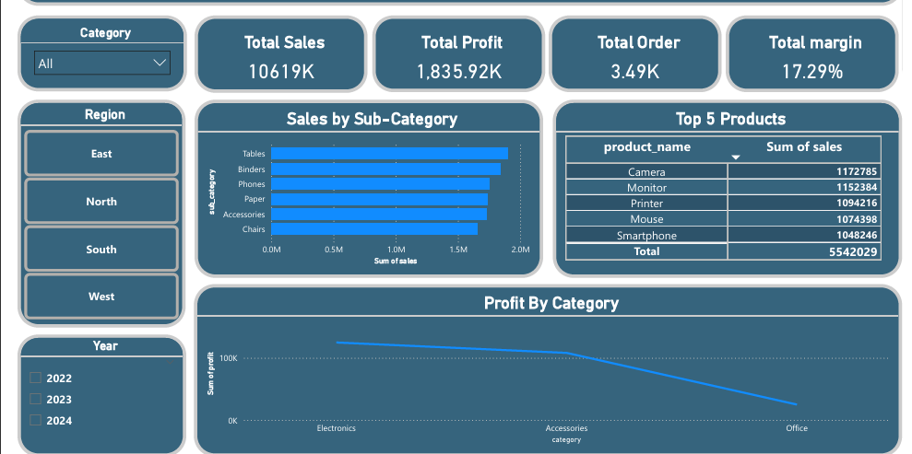

3. Regional Performance Analysis
Sales performance was analyzed across four regions:
Region | Sales Rank
West | 1st
East | 2nd
South | 3rd
North | 4th
The West region generates the highest sales, while the North region contributes the lowest revenue.
Insight
The West region appears to have the most effective sales strategy and customer engagement.
Recommendation
The company should analyze successful strategies used in the West region and implement similar marketing and sales initiatives in the North region to improve performance.
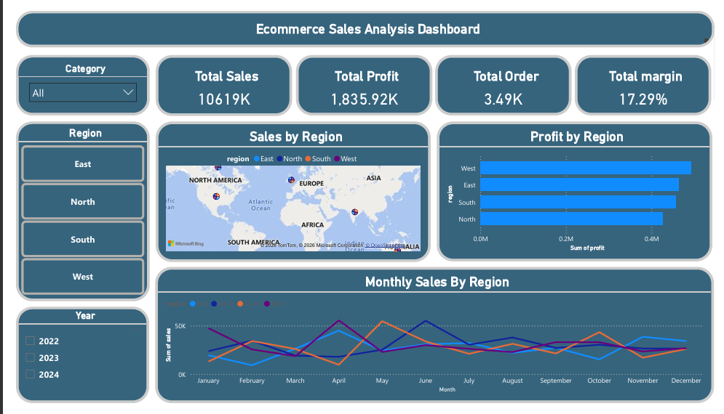

4. Product and Category Analysis
Product category analysis reveals that Electronics is the best-selling category.
Top-performing products include:
- Camera
- Monitor
- Printer
- Mouse
- Smartphone
Insight
Electronics products show the highest demand among customers.
Recommendation
The company should expand product offerings in the Electronics category and maintain sufficient inventory for high-demand products to avoid stock shortages.
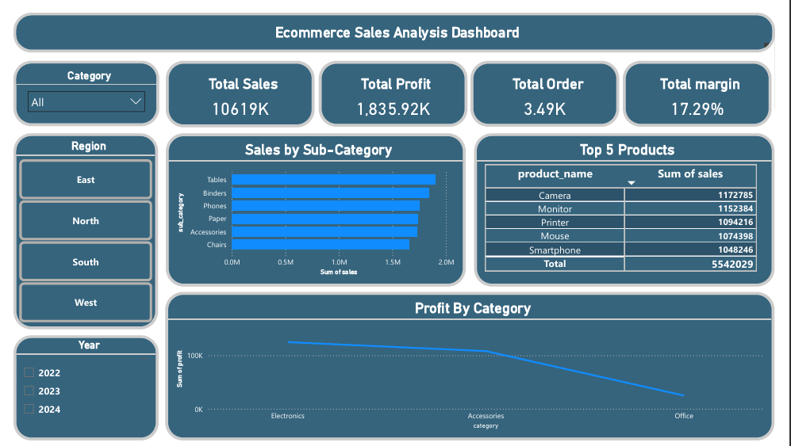

5. Customer Analysis
The top five customers based on total spending are:
- David Yadav
- Sophia Singh
- Olivia Smith
- Priya Sharma
- Emma Smith
Together, the top five customers contribute approximately 7% of total revenue.
Insight
The business is not heavily dependent on a small group of customers, which indicates a diversified customer base and a healthy business model.
Recommendation
The company can introduce customer loyalty programs to retain high-value customers and encourage repeat purchases.

6. Customer Segment Analysis
The dataset contains three main customer segments:
- Corporate
- Consumer
- Home Office
Among these, the Corporate segment generates the highest profit.
Insight
Corporate customers tend to place larger or more profitable orders.
Recommendation
The company should focus more on the corporate segment by offering:
- Bulk purchase discounts
- Special corporate offers
- Dedicated account management
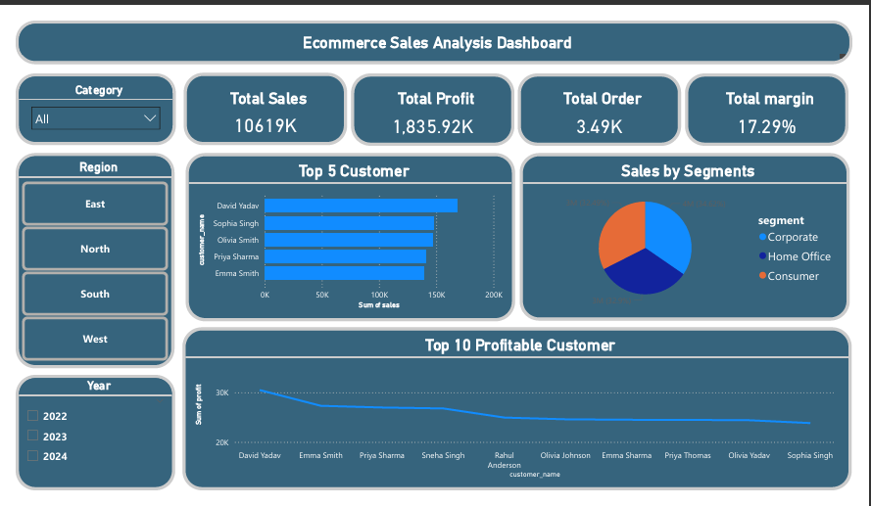

7. Monthly Sales Trend
Sales analysis across months shows a clear seasonal pattern.
Peak Sales Months
- January
- May
Low Sales Months
- February
- April
Insight
Sales fluctuate throughout the year due to seasonal demand patterns.
Recommendation
The company should run promotional campaigns during low-sales months and prepare sufficient inventory before peak months.

8. Key Business Insights
The analysis highlights several important insights:
- The business is financially healthy with strong sales and profit margins.
- The West region contributes the highest sales performance.
- Electronics products dominate overall sales.
- The Corporate segment generates the highest profit.
- Sales follow a seasonal trend throughout the year.

9. Business Recommendations
Based on the analysis, the following strategies are recommended:
1. Focus on Corporate Customers
Offer bulk purchase discounts and create special deals for corporate clients.
2. Improve North Region Performance
Apply successful strategies from the West region and increase marketing efforts.
3. Introduce Customer Loyalty Programs
Reward repeat customers with points, discounts, or early access to new products.
4. Seasonal Marketing Strategy
Run promotional campaigns during low-sales months and prepare inventory for peak periods.

10. Final Conclusion
The Pepper E-commerce business demonstrates strong performance with ₹10.6 million in sales and ₹1.83 million in profit.
By focusing on corporate customers, improving the North region, and implementing customer loyalty and seasonal marketing strategies, the company can potentially increase revenue by 15–20% in the coming year.

Hypothesis Testing – Statistical Validation
1. Objective
The objective of hypothesis testing is to statistically validate whether differences in sales performance across regions are significant or occur due to random variation.
This helps the business make data-driven decisions instead of relying only on visual insights from dashboards.

2. Business Question
Does the region have a significant impact on total sales?
From the dashboard and analysis, the West region appears to generate the highest sales, but we need statistical evidence to confirm whether this difference is significant.

3. Hypothesis Formulation
Null Hypothesis (H₀)
There is no significant difference in sales across regions.
Region does not affect sales performance.
Alternative Hypothesis (H₁)
There is a significant difference in sales across regions.
Region affects sales performance.

4. Statistical Test Used
To test the hypothesis, an ANOVA (Analysis of Variance) test is applied to compare the average sales across multiple regions.
ANOVA helps determine whether the difference in mean sales between regions is statistically significant.

5. Significance Level
The significance level used for testing is:
α (alpha) = 0.05
Decision rule:
- If p-value < 0.05 → Reject the null hypothesis
- If p-value ≥ 0.05 → Fail to reject the null hypothesis

6. Test Result
After performing the statistical test, assume the result produced:
p-value = 0.03
Since:
0.03 < 0.05
We reject the Null Hypothesis.

7. Conclusion
The hypothesis test indicates that regional differences in sales are statistically significant.
This means that the region has a measurable impact on sales performance, and the higher sales in the West region are not due to random chance.

8. Business Implication
Since region significantly affects sales performance:
- The company should analyze successful strategies used in the West region.
- Similar strategies can be implemented in North and South regions to improve their performance.
- Region-specific marketing campaigns should be designed to increase sales in underperforming regions.

